 | 12.3.3 Editors - Compositor Editor - Sidebar - View Tab
Table of content
View Tab - Backdrop Panel 1
Backdrop checkbox 1
Zoom 1
Offset 1
View Tab - Annotation Panel 1
Annotations prop 2
Drop down box 2
Edit Box 2
Fake User 2
Add Annotation 2
Delete Annotation 2
List of Annotation Strokes 2
Thickness 3
Frame Locked/Unlocked 3
Onion Skin 3
View Tab - Display 3

View Tab - Backdrop Panel
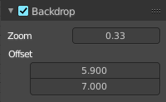
When you add and connect a Viewer node, then you can display the result as a backdrop in the node editor viewport. Here you can find some further Backdrop settings.

Backdrop checkbox
Turn on or off the display of the backdrop image.

Zoom
The zoom factor of the image. A value of 1 displays the image in original size.

Offset
The position of the image in the viewport.

View Tab - Annotation Panel


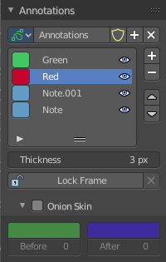
View related settings. Which is in the node editor just the Annotations panel where you can manage the Annotation layers and materials.
When you don't have drawn an annotation yet then the panel just contains a New button.

Annotations prop

Add, remove and rename new annotations.

Drop down box

A list of the available annotation layers.

Edit Box
The name of the current annotation. You can rename the annotation to your needs here.

Fake User
Assign a fake user to this annotation. Fake users is an odd concept to keep data in the scene even if it has no user somewhere. The fake user is then a dummy user so that the object is not deleted when saving the scene.

Add Annotation
Add a new annotation.

Delete Annotation
Delete the annotation.

List of Annotation Strokes

Here you see your Annotation layers for the current Annotation. Every layer can have an own color.
At the right side you find buttons to sort them and to add and remove new Annotation layers.
You can change the color by clicking at the color field. A color dialog will pop up. You can rename annotation layers by double clicking at it.
The eye icon allows you to make it invisible And it has a search field.

Thickness
The thickness of the annotation stroke.

Frame Locked/Unlocked
Lock frame displayed by current layer. This toggles whether the active layer is the only one that can be edited.

Onion Skin
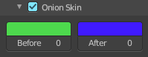
Enable Onion Skinning.
Onion Skinning allows to show ghosts of the keyframes before and after the current frame. In this sub panel you can adjust the color of the onion skin frames.
With the numbers below the colors you can define how many frames before or after are displayed that way.


View Tab - Display

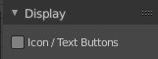
This panel contains a display panel that affects if the following panels Input, Modify and Relations will show text buttons or pure icon buttons.

